SPARK: Simple Play Adaptations to Reference for Kids

Big Step-by-Step
Description: | Image:
The Big Step-by-Step is a sequential voice output communication device. Pressing the large button on the top of the device activates a message. With each subsequent press of the button a new message is activated. The button is approximately 5” in diameter. Four different color top choices are provided, which snap over the activation button. The device comes with a clear snap cover allowing a picture symbol to provide communication context for the user. The Step-by-Step has 4 minutes of total record time with three different recording levels of message storage. A switch on the side of the device can be toggled to change the desired level for the user. The device is powered by a 9-volt battery. | 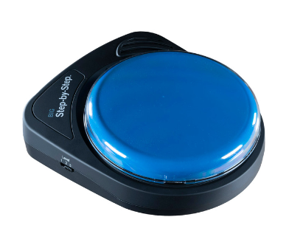  Purchasing Information  Getting Started Video  Quick Start Guide  User’s Manual  Troubleshooting

Who Might Benefit?
Those who…
• Need communication supports due to challenges with verbal communication.
• Need structure to engage in back and forth communication exchanges.
• Have difficulty attending, listening, and remembering step-by-step directions for activity completion.
• Need effective ways to engage in independent literacy and other content related activities.
• Have adequate fine motor skills to reach and press to activate the button on the device. This skill is specific to this device, however there are many different access methods that can be used with other communication devices if needed.

Why Use?
Provides an opportunity to…
• Engage in simple reciprocal communication exchanges with peers, staff, and parents.
• Hear step-by-step directions repeated as needed.
• Independently listen to books and other content delivered in a sequential method.
Instructions for Use: | Adaptation Ideas:
Environmental Considerations  - Can be easily used in almost any environment because of the small size, weight, and easy transportability.  - May be difficult to use in loud environments as the speaker on the device may not be loud enough to be heard by the child or communication partner.  - The user of the device will need to learn when it is appropriate to use the device in quiet environments in the same way that children who are speakers learn when they need to talk or not talk in quiet environments.  - If the device is used as a part of a child’s total communication system it should be available in the child’s environment and without restriction, at all times.  Positioning  - Can be used in most any position due to the size, portability, and minimal weight (on a tabletop, attached to a wall with Velcro, placed on the floor, positioned on a slant board, etc.).  - Interact with the device in different positions such as sitting, standing, prone (Tummy Time position), supine (laying on back), kneeling, etc.  Alternate Positioning  - The Big Step-by-Step can be mounted onto the Ablenet Large Triangluar Mounting Plate (not included) and then on a variety of mounting systems that can be either connected to a table or wheelchair for alternate positioning if needed by the child. The linked guide provides directions for mounting the Step by Step.  Basic Play/Use  - Insert the provided alkaline 9-volt battery into the device.  - Turn device on and select desired level.  - Press and hold record button until recording indicator light turns on.  - Press and hold colored switch top. Begin speaking into microphone after you hear beep. When done recording message, release colored switch top.  - Repeat the previous two steps to record additional messages.  - Press the record button to turn the recording indicator light off.  - Optional: Select a different recording level to record a second and third set of messages.  Extended Play/Use  - Provide the child support to complete sequential directions, such as following a classroom schedule or sequential steps in a learning activity.  - Making requests, such as ordering food or asking multiple questions.  - Participate in sequential activities, such listening to pages of a book being read aloud or listening to a social story.  - Share information, such as upcoming events or directions for a classroom cooking activity.  - Use as labels for areas or centers, as teaching prompts, or to greet others upon entering the classroom every morning.  - Play the sequential steps of washing hands (e.g., turn on water, get hands wet, put soap on hands, etc.)  Play/Use with Others  - Participate in reciprocal communication exchanges (Social Scripts) with others.  - Make games interactive by modifying a game to talk or playing the sequential steps of a game. | Optional Additional Materials/Supplies  - Dycem or shelf liner.  - Velcro  Stabilize It  - Can be stabilized with either Velcro, Dycem, or shelf-liner.  Simplify It  - A single repeating message can be recorded on the device rather than each message being different.  Add Sensory Cues  - Add sensory cues to the activation button such as puffy stickers, puffy paints, different textures.  - Change the color of the button by replacing the color cap with one of the additional colors provided.  Communication Support  - Vocabulary words will depend on the activity supported by the AAC device.  Alternative Uses  - Multiple GoTalk Ones can be placed side-by-side and velcroed onto a foam board strip to allow a child: choices among several toys or activities, providing a visual and auditory cue for the sequence and steps in an activity, provide first/then support, or to sequence and construct a simple sentence, etc.  - A switch input jack is also on the device which allows an external switch to activate the message rather than the built-in button on the top of the device. This allows more customization of the size of the activation surface.  - Activate switch-adapted toys or appliances with this device. Plug any switch-adapted toy or appliance into the Toy/Appliance jack. While recording a message, press the Record Button one time to assign a toy or appliance to that message. When that message is played, an attached toy or appliance will activate for the length of the recorded message.

Additional Considerations:

Please keep in mind the device only has 4 minutes of recording time. If additional recording time is needed there are other AAC devices available in the OCALI Lending Library that could offer extended recording and play time.

Resources:
- Why We Love Sequential Message Devices/Apps - Carol Zangari, 2012
- 101 Ways to Use Sequential Message AAC Device to Access the Curriculum - Teaching Learners with Multiple Special Needs. Compiled by Toni Waylor-Bowen, Ph.D. & Jessie Moreau, M.Ed., NBCT; March 2007.
- Sample Sequenced Social Scripts - Linda Burkhart and Carolyn Musslewhite, Closing the Gap, 2001.
- Anatomy of A Conversation: Social Scripts Suggested Conversational Messages – Linda Burkhart and Carolyn Musslewhite, Collected from multiple workshops, (2000-2001).

Ohio Early Learning Standards:
- Depending on the activities supported by the AAC device a wide range of Early Learning Standards could be impacted.

Words to Encourage Play/Use
Push  | Listen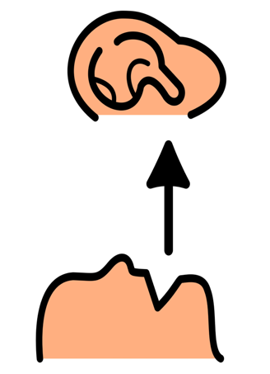 | All Done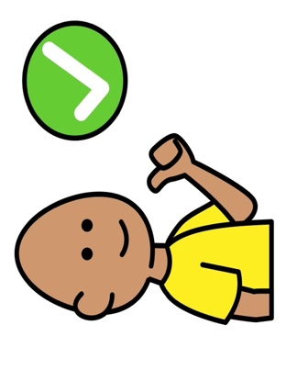
My Turn | Your Turn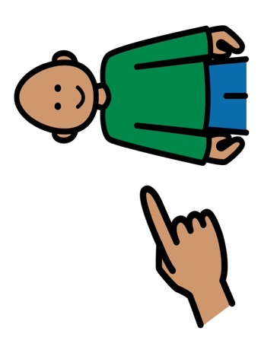 | More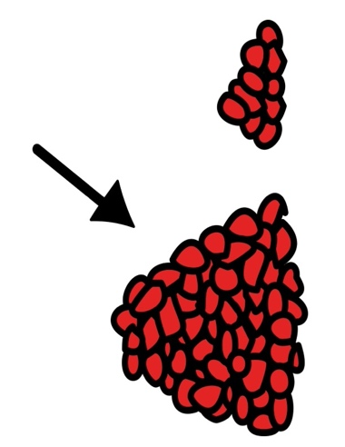
Wait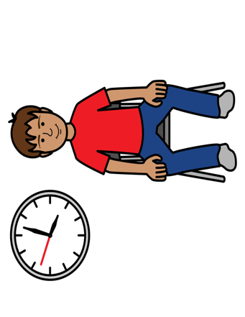 | Stop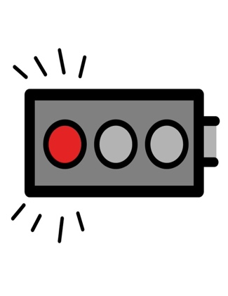 | Go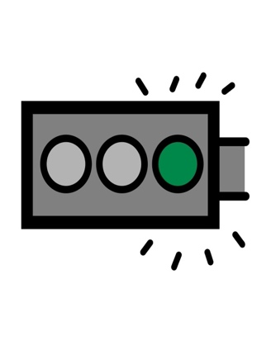
*”Adaptations” adapted from: Haugen’s Modes for Adapting Toys based on materials from the "Let's Play" Project at the University of Buffalo
PCS is a trademark of Tobii Dynavox, LLC. All rights reserved. Used with permission.

